|  |
| --- |
| Style Guide |
| Liliya Artyukh’s Portfolio Website |
| Liliya Artyukh, 300702887 |

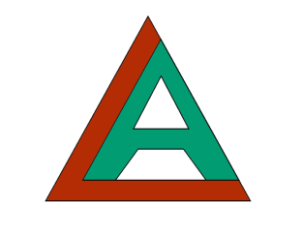

Table of Contents

[Description 2](#_Toc410502406)

[Nav Bar Functionality 3](#_Toc410502407)

[Colors 4](#_Toc410502408)

[Typography 5](#_Toc410502409)

[Wireframes 6](#_Toc410502410)

[Branding 1](#_Toc410502411)

[Services page 2](#_Toc410502412)

[About Me page 3](#_Toc410502413)

[Contact Me page 4](#_Toc410502414)

[Home Page 5](#_Toc410502415)

[GitHub 6](#_Toc410502416)

[References 7](#_Toc410502417)

# Description

The website is created with a goal to provide access to potential employers and other interested parties to information about work I have done.

The website includes:

* Biography page with a bit of information about me
* Services page that describes what work I am capable and interested in doing

Portfolio page featuring my work

* GitHub link to my source code
* Home page that serves as an introductory welcome page that summarizes website’s content
* Contact me page with my contact details

The website is built around modern web design. Big font, images and little text are the key elements of style used. Website is responsive to ensure users being able to go on it on a variety of devices without compromising visual appeal.

Technology used to build the website are CSS, HTML, Bootstrap, JQuery.

Best practices are used when it comes to separation of .css, .js, and .html files. Assets are organized in fodders: images and scripts.

# Nav Bar Functionality

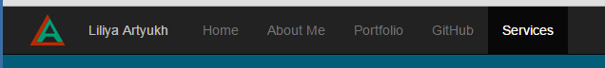

Bring user to home page

Bring user to biography page

Bring user to Portfolio page

Bring user to GitHub

Bring user to service page

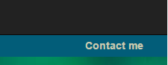

Takes user to contact information page and email form

Below are screenshots of nav bar when the screen is small. See menu closed and expanded view.

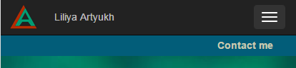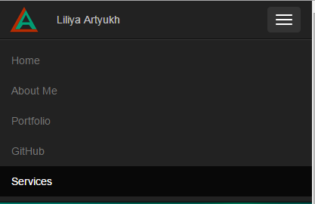

# Colors

Below are the colors used in the website design.

|  |  |  |
| --- | --- | --- |
| **Where used** | **code** | **example** |
| Links - hover |  |  |
| Logo , links |  |  |
| Background for contact me, links |  |  |
| Links, hints, notes |  |  |
| background |  |  |
| logo |  |  |
| Background footer |  |  |

# Typography

Font for this website was the default font of Bootstrap.

**Example of default font sizes**

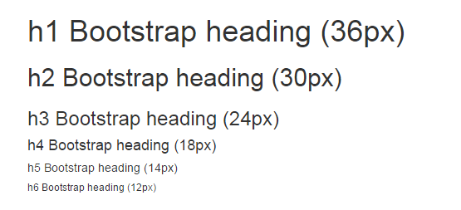

**Typography table**

|  |  |  |  |  |  |
| --- | --- | --- | --- | --- | --- |
|  | example | color | font-weight | font-size | tag |
| Page Headings |  | #333333 | 200 | 63px | h1 |
| Subtitles |  |  |  |  | h2 |
| paragraphs |  |  |  |  | p |

# Wireframes

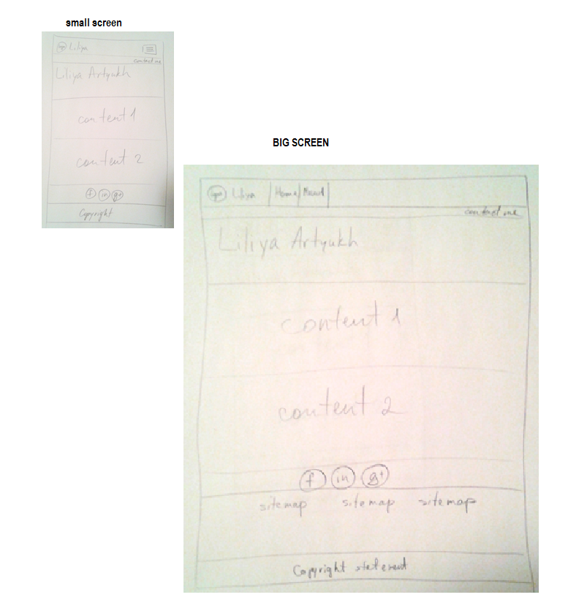

# Branding

Logo

|  |  |
| --- | --- |
| **code** | **example** |
|  | **E:\111 winter 2015\Emerging technologies\portfolioWebsite\images\logo_small.png** |
|  |

## Services page

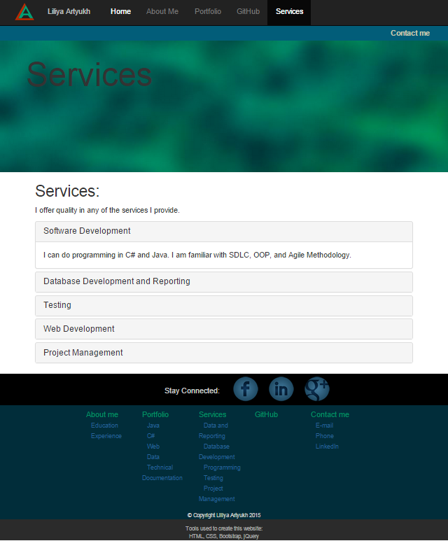

## About Me page

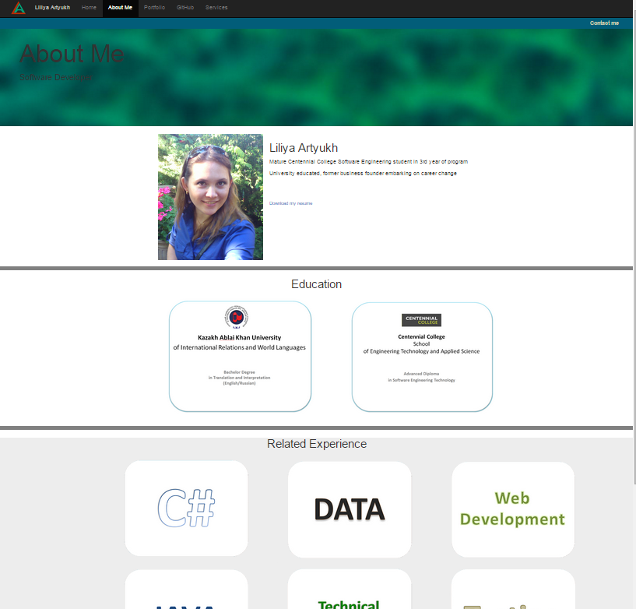

## Contact Me page

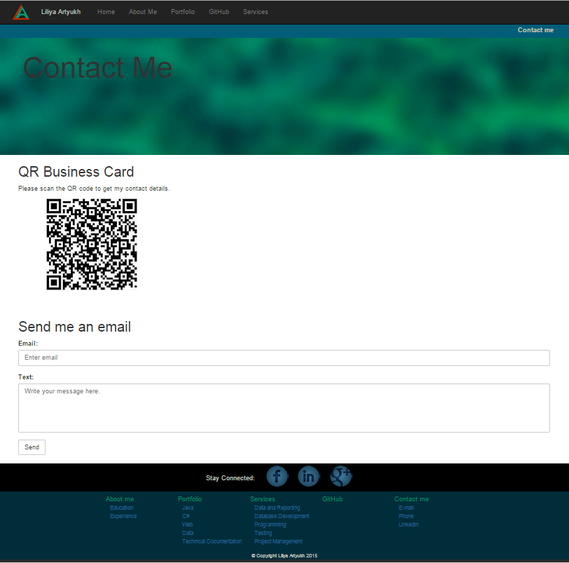

## Home Page

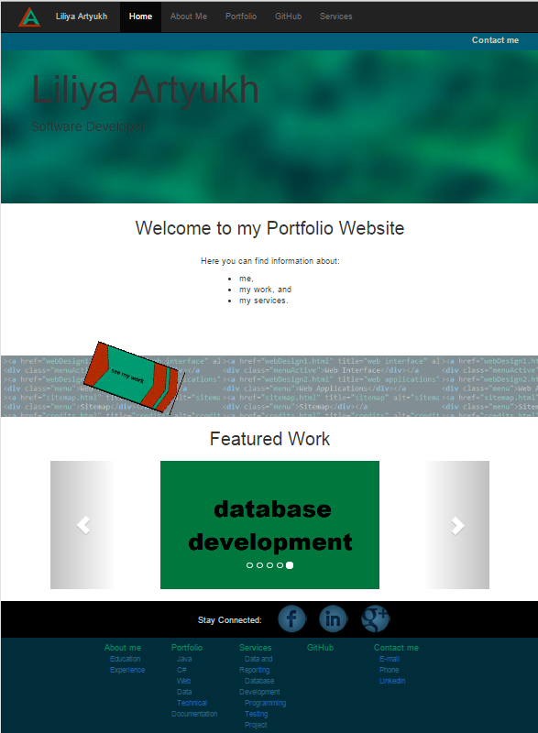

# GitHub

The source files can be found on GitHub. The webste itself is also hosted on GitHub.

Link to the GitHub: <https://github.com/liliya0artyuh/liliya0artyuh.github.io>

Link to website: <http://liliya0artyuh.github.io/index.html>

**Records of code submissions on GitHub**

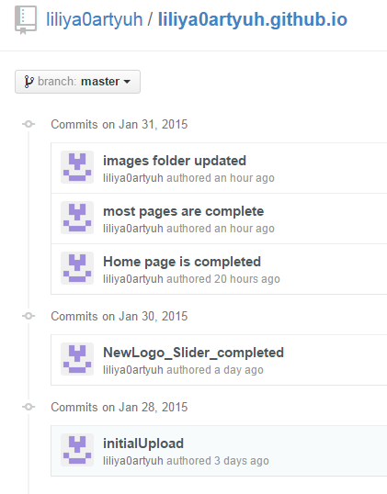

# References

Typography information

<http://www.w3schools.com/bootstrap/tryit.asp?filename=trybs_txt_hn&stacked=h>

Bootstrap, CSS, HTML, jQuery

<http://www.w3schools.com/html/default.asp>